2020 European Young Masters

Golf Mladá Boleslav, August 27 – 29
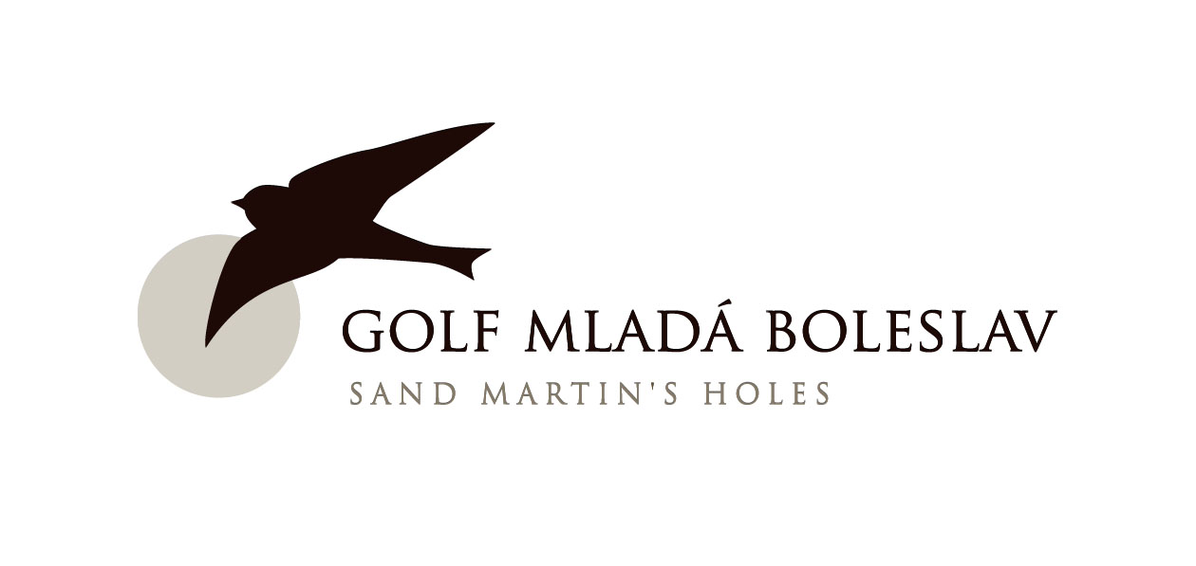

ACCOMMODATION
BOOKING FORM

COUNTRY: _________________________________________________________
RESPONSIBLE PERSON: _________________________________________________________

Telephone: ________________________Fax: __________________________ E-mail: _____________________
Please indicate the number of required rooms

Hotel Sand Martin

# OF SINGLE ROOMS: ______________________
# OF DOUBLE ROOMS: ______________________

Rooms will be allocated on a first come first serve basis
Room Policies: Reservation will NOT be considered confirmed until the Coordinator has received a credit card number valid at least until November 2020. Payment and Cancellation Policies: These will be communicated with you directly by the Coordinator upon receiving your completed Accommodation Booking Form.

Card name: _______________________________________________

AmEx, VISA, MasterCard, Diners Club, JCB, Maestro (please circle one)

Number: ________________________ Exp. Date: ________________ Sec. code: _______________

DATE OF ARRIVAL: ________________________ DATE OF DEPARTURE: ____________________

Name and e-mail: __________________________________________________________________

Date and signature: ______________________ Federation stamp: __________________________

Accommodation Booking Form has to be sent to Coordinator by
July 31, 2020: miroslav.elicer@hotelsandmartin.cz

2020 European Young Masters

Golf Mladá Boleslav, August 27 – 29
TEAM TRAVEL
DETAILS FORM

COUNTRY: ________________________________________________________________________

Arrival by car: □ Arrival by air: □
(tick appropriate)

DATE OF ARRIVAL: ___________________________ FLIGHT NUMBER: ___________________

TIME OF ARRIVAL: __________ _________________ TERMINAL: ________________________

No. of LUGGAGE: ___________ No. of GOLF BAGS: _________ No. of PERSONS: ________

CAPTAIN´S NAME: ___________________________________________________

CAPTAIN´S MOBILE PHONE #: __________________________________________

DATE OF DEPARTURE: ___________________________ FLIGHT NUMBER: ___________________

TIME OF DEPARTURE: _______ ____________________ TERMINAL: ________________________

No. of LUGGAGE: ___________ No. of GOLF BAGS: _________ No. of PERSONS: ________

Date and signature: ________________________________________________________

Team Travel Details Form has to be sent to the CGF by
July 31, 2020: cgf@cgf.cz

2020 European Young Masters

Golf Mladá Boleslav, August 27 – 29
TEAM MEMBERS
INFORMATION FORM

Please note: all players must be born in 2004 or later
maximum HCP for girls is 16; maximum HCP for boys is 12

COUNTRY: ___________________________________________________________________

BOYS:

PLAYER: ________________________________ Date of Birth____________________ HCP: ______

PLAYER: ________________________________ Date of Birth____________________ HCP: ______

GIRLS:

PLAYER: ________________________________ Date of Birth____________________ HCP: ______

PLAYER: ________________________________ Date of Birth____________________ HCP: ______

TEAM CAPTAIN: ____________________________ MOBILE PHONE No.: ______________________

E-MAIL ADDRESS: ___________________________________________________________________

TEAM ADVISOR: ____________________________ MOBILE PHONE No.: ______________________

E-MAIL ADDRESS: ___________________________________________________________________

No. of ADDITIONAL PEOPLE TO ARRIVE WITH THE TEAM: ___________________________________

Date and signature: ________________________________________________________

Team Members Information Form has to be sent to the CGF by
August 14, 2020: cgf@cgf.cz

