European Ladies’ Amateur Championship 2020

Confirmation of participation

To whom it may concern,

With this letter we would like to confirm that

Ms (full name):_____________________________________________________
Telephone:_____________________________________________________
E-Mail:________________________________________________________

is on the list of players for European Ladies’ Amateur Championship 2020.

Athlete’s accompanying team (full name, telephone, E-mail):

1._______________________________________________________________________

2._______________________________________________________________________

Name & Signature/Stamp of the National Golf Authority:

_______________________________________________________________________

The event is under organisation of European Golf Association and Slovenian Golf Association and
it is taking place from 28. September to 3. October 2020 at GC Cubo, Smlednik, Slovenia.

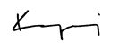
EUROPEAN GOLF ASSOCIATION SLOVENIAN GOLF ASSOCIATION
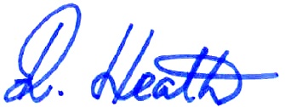
Richard Heath Gorazd Kogoj
General Secretary General Secretary

